# The marketing process, market definition & analysis; the environment, BtoC Marketing, BtoB Marketing, SWOT Analysis

## 1. Introduction to Marketing

## 2. Understanding The Market

### Market definition

### Demand analysis

### Trends

### Competitor Analysis

### Customer behavior and decisions analysis:

### “Micro” level analysis of demand - Customer behavior analysis and decisions (BTC)

* 1. Characteristics
  2. “Stimulus-response” Model
  3. Buying decision process

1.Recognition or anticipation of the problem/need, 2.Definition of the functional and/or technical specifications, 3.Search for information, 4.Requests for an offer, 5.Evaluation of alternatives, 6.Decision, 7.Post-purchase

* 1. Roles involved in the buying process(INITIATOR-INFLUENCER-DECIDER-BUYER-USER)

### “Micro” level analysis of demand - Customer behavior analysis and decisions (BTB)

* 1. Characteri stics
  2. “Stimulus-response” Model
  3. Buying decision process
  4. Roles involved in the buying process

## 3. Assessing The Market Position

### Market share

1. Brand KPI

## 4. The Logic Of The "Swot" analysis process

Tows Matrix

# Segmentation

## 1. Segmentation

### A. The objectives of segmentation

Segments and their characteristics

Advantages and disadvantages of segmenting

### B. The approaches and the process of segmentation

* “UNDIFFERENTIATED MARKETING” (OR MASS MARKETING)
* “Segment marketing” [Mass, Segmented, Niche *Concentrated*, Micro]
* “ONE-TO-ONE MARKETING”

### C. The methods of segmentation

Mathematical

Survey research

Heuristic

• Successive elimination approach (Porter, 1987)

• Two-phase approach (Wind and Cardozo, 1974)

• Multi-phase approach “Nested approach” (Bonoma and Shapiro, 1982)

## 2. Targeting

## 3. Buyer’s Persona and Buyer’s Journey

## 

# Positioning

## 1. Positioning

## 2. Positioning tools

* Perception map
* Value curve

## 3. Re-positioning

## 

# Marketing mix: Introduction Product - Service - Experience

## 1. Introduction to marketing mix

## 2. Product

### Key element for a product in marketing

A. The product «5 level»: Potential << Augmented << Expected << Basic << Core benefit

B. The voice of the customer

C. Product life cycle

D. Product line assortment

E. Product strategy formulatio

F. New product development

## 3. Service

## 4. Experience

# Branding

## 1. Brand

## 2. Brand positioning

## 3. Brand Portfolio and Architecture

brand relationships:

✦ Branded house

✦ Sub brands

✦ Endorsed brands

✦ House of brands

# Pricing

## 1. Basic elements of pricing

## 2. Steps to set the price

### 1.Defining pricing objectives

### 2.Forecasting demand

### 3.Cost estimation and marginality

### 4.Analysis of competitors’ behavior

### 5.Selection of the pricing method (3 C model: ceiling price - costs - competitor’s price)

Cost-based pricing:

markup pricing

break even pricing

target return pricing

Customer-based pricing:

perceived value pricing

Competitor-based pricing:

going-rate pricing

### 6.Pricing decision

Psychological factors influence price perceptions!:

Decoy effect (3-4-6)

Anchoring effect (fixate the benefits)

## 3. Dynamic pricing and Yield management

# Distribution

## 1. The concept of distribution

## 2. Typology of channel

direct channel

indirect channel

## 3. Typology of intermediates

Push and pull strategies

## 4. Designing the distribution channel

1.Determining the customer service

2.Setting objectives and fixing constraints

3.Identifying alternatives

4.Evaluating alternatives

## 5. Marketing systems

Vertical marketing systems - franchising system (a particular form of vertical system)

Horizontal marketing systems

## 6. Digital and multichannel environment

## 7. Trade marketing

# Communication

## 1. Integrated Multichannel Communication

Types of communication:

* # 1. Institutional (corporate) communication
* # 2. Commercial communication
* # 3. Internal communication

## 2. Communication process

### 1.Defining the target

### 2.Defining objectives of the communication plan

### 3.Developing the message to convey

### 4.Selecting the channels

### 5.Defining the communication budget

### 6.Defining the communication mix

### 7.Performance assessment

## 3. Communication Mix

A. Advertising:

B. Sales promotion:

C. Sponsorships and PR

D. Direct marketing:

E. Personal selling:

## 4. The New Media Mix

### Before: interruption media

Owned media

Paid media

+ display advertising

### Now: interaction media

Owned media

Paid media

* Earned media
* Sold media
* Hijacked media
* Native adv, content, Interaction, and co-creation

### Types:

1. Viral Marketing

2. Digital Public Relations (Digital PR)

3. Unconventional Pr

4. SEARCH & SEO

5. SEARCH Ads

6. Display ads:

Banner/Strip/Masthead/Microsite/Overlay (or floating ad)/Pop-up/

7. Mobile Push Notifications Marketing

8. Content Marketing

9. Social Media

10. Email Marketing

11. Affiliate Marketing

12. Community Building

13. Native Advertising

14. PROGRAMMATIC ADVERTISING -> REAL TIME BIDDING PLATFORM

# Digital attribution models

—-------

| 1 | 24 |  | 12 |  |
| --- | --- | --- | --- | --- |
| 2 | 36 |  | 14 |  |
| 3 | 50 | - | 10 |  |
| 4 | 60 |  | 11 |  |
| 5 | 71 |  | 11 |  |
| 6 | 82 | - | 3 |  |
| 10 | 85 |  | 34 |  |
| 7 | 119 |  | 18 |  |
| 8 | 137 |  | 11 |  |
| 9 | 148 | - | 10 |  |
| 13 | 158 |  | 8 |  |
| 11 | 176 |  | 8 |  |
| 12 | 184 |  | 11 |  |
| 14 | 195 |  | 22 |  |
| 15 | 217 |  | 8 |  |
| 16 | 247 |  | 21 |  |
|  | 268 |  |  |  |

Oral

# Startegy:

# Marketing:

*Questions S&M 2023-24*

Ghezzi - Questions

(He's just asking questions on Strategy)

Real world case - Activision Blizzard Acquisition from Microsoft, why almost 900 employees were laid-off. Which model did they consider before performing the acquisition? (Corporate Portfolio analysis, deep diving in it with the BCG Matrix)

Strategic consideration to draw in case you are taking the management of your family business (A wood & toys company)

Model or tools to design value proposition of a well established company, Blue Ocean Strategy and 6 innovation Path

5 forces model - Scale Economies and Scope economies in Threat of new entrants (what is on the axis of those charts?)

—

He asked me to classify Chat Gpt as type of innovation

He asked me to explain the business plan and the financing stage for startup

Cellini - marketing process, blue ocean, vertical marketing distribution

He doesn’t give any cases, just asks theory and to provide examples for everything

For me I was asked to describe value chain model of two companies of my choice.

I chose Samsung and IPhone in the smart phone industry. Then he asked me about their marketing and communication strategies.

Magnaghi will ask questions about project, for example, value proposition of EVOCA

Moiana

1. Which are the different layer of strategy? Can u tell me some examples?

2. Tell me some examples of corporate strategy and business strategy

3. Differences between strategic and tactical decision and give me some examples.

1. Which kind of advantage?

2. What are the sustainable competitive advantage? What does it mean?

1. Speak about what is the internal and the external analysis. What are the tools to run an external analysis.

2. Talk about PESTEL.

3. Tell me about the RBCV. What are the 5 core test?

1. How can we use external analysis to define a CA? where we can find it the strategic definition path? (Orientation, Analysis …)

2. What about the BMC? What should explain the different block of the BMC?

Niccolò

1. E commerce, what resources can be used?

1. What do u think of vertical integrating?What are the reasons to do it?

2. Why do not do acquisition?

3. What is branding house?

1. Can u explain to me the differences about capex and opex?

I was with cellini, he asked me:

- the 4P and what are the other 3Ps, with examples

- ⁠Points of parity and Points of Difference, with an example of a downstream pod

- ⁠Brand KPIs (awareness, recognition, recall) with some examples of companies with positive performance in these KPIs

- ⁠The marketing process of a new product

I was with Moiana:

He asked me about how can traditional companies defend themselve against disruptive Innovations, what is the difference to Big Bang?

What about Blue ocean and whats the difference?

Now about BM Canvas? What changes if we want to expand the Company into another markets?

Which Parts do Change the most?

I was with cellini:

- acqualisa case

- step of communication

- example od bad communication

- yield manager

- relationships brand

- the pro of segmentation

I was with Cellini, it was super fast, no more than 7 min. Asked me about yield management, the branding process and just the difference between a broker and an agent

—-

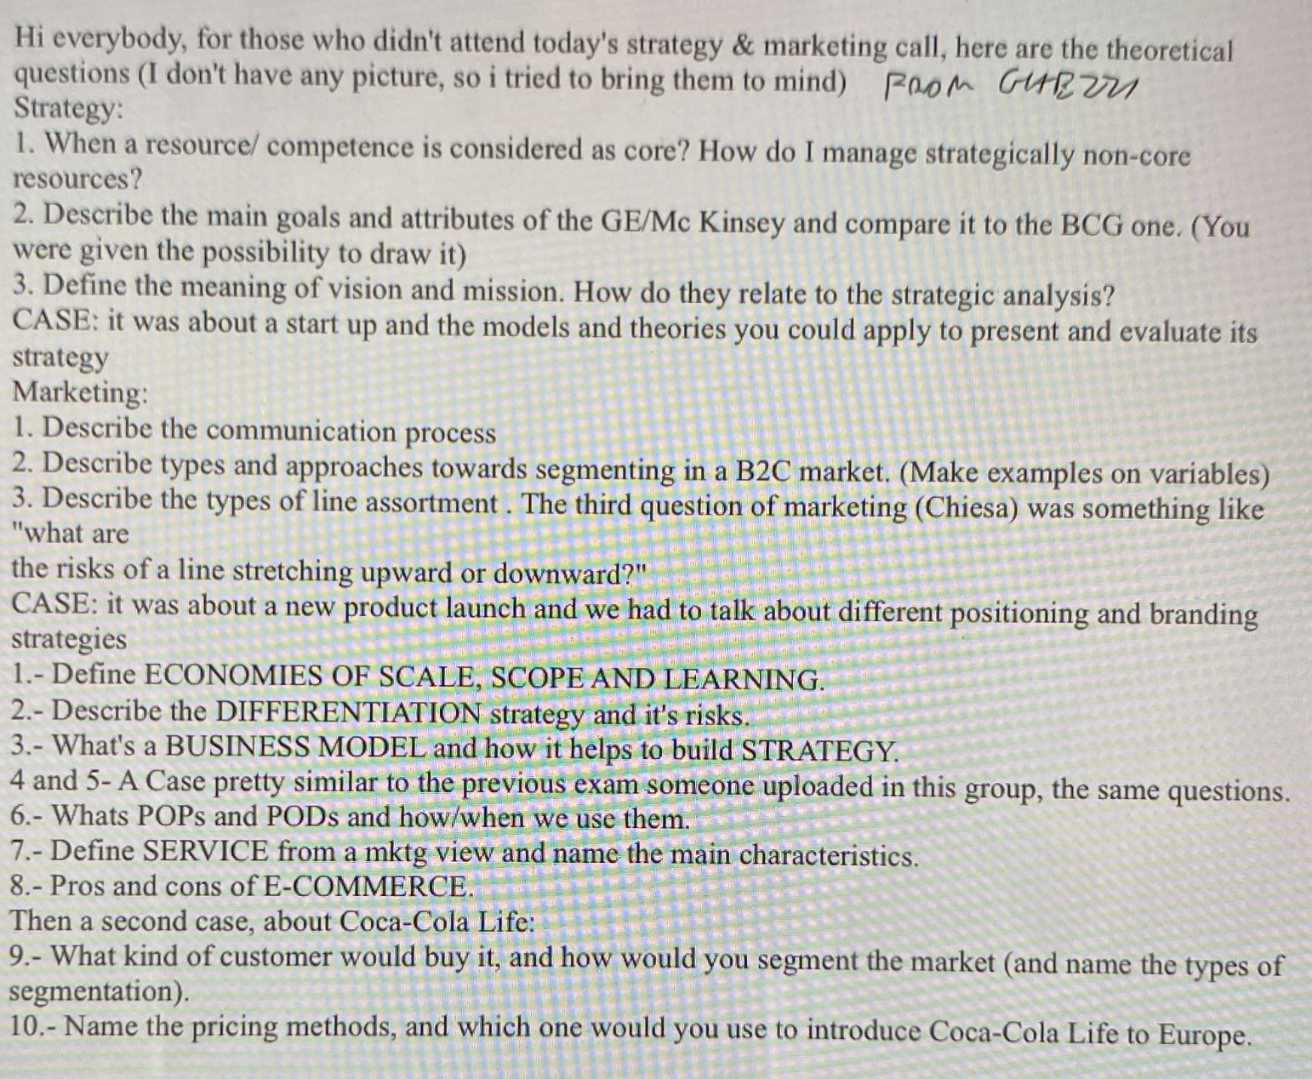

—-

<https://www.handouts.it/ghezz/>

<https://www.handouts.it/home/politecnico-di-milano/newgestio/sm-strategy-marketing/>

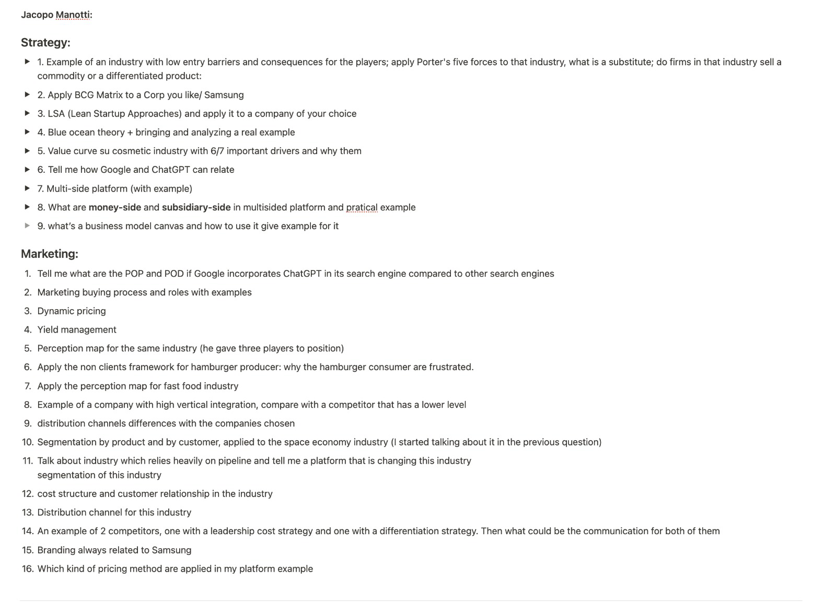

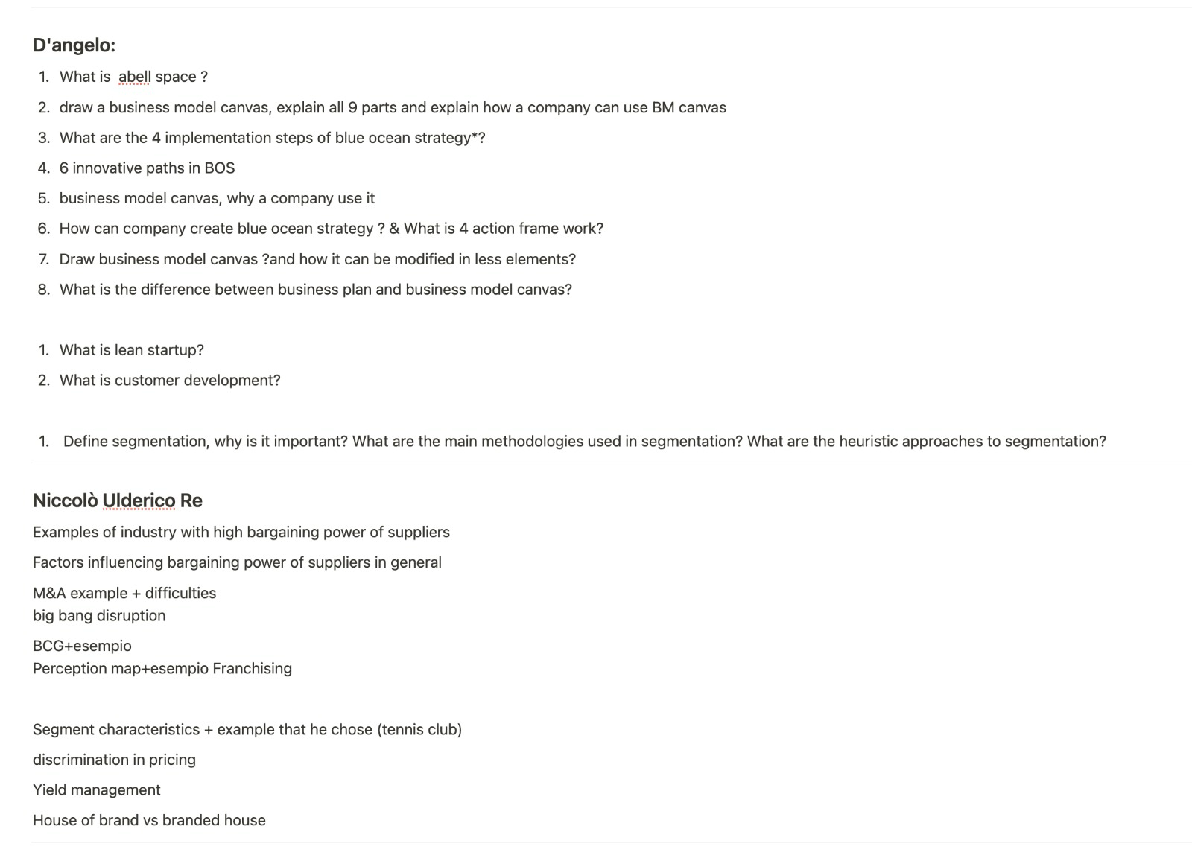

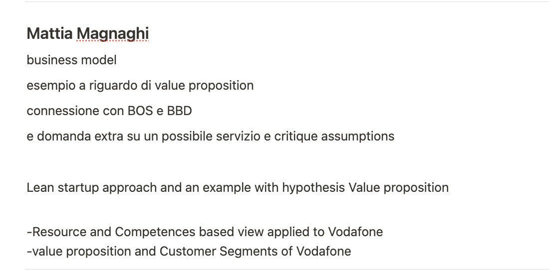

D’angelo 21-2-222 interrotta

- Lanzavecchia

o Value chain: objectii\ves, limits, describe single components of value chain

Sanasi 20-1-22

- Manotta 21 (lack of preparation) à final 22

o BCG matrix, apply it to real case. What do you mean with balanced portfolio? Why do we have relative market share? CASE EXAMPLE where would you put ipad? Cash cow. Airpods? Cash cow.

o Can you in a few minutes BM of Facebook? Asked to use a different example (AirB&B fatto in classe) and she said ok.

- Momo 25 (you understood everything, but you are not too precise) à 24

o Real case: example of a company identified as Blue Ocean. Run the Blue Ocean strategy on that. Netflix. Tell me the 4 steps?

- Serjei 19 (lot of holes) à 19

o Real case: what’s the business model of Facebook using business model canvas? Difference between key activities and value proposition?

o Can you analyze Facebook under the multisided platform strategic? Effects to apply to this case? What is the definition of a multisided platform and how is Facebook one of this?

- Guan 18 OVERALL DOVEVA BOCCIARE

o Example of big bang disruption? Didn’t know difference between this and disruptive innovation.

o Disruptive innovation? Digital cameras. Characteristics of disruptive innovations? not very precise

- Momo 2 19 (know some of the things nut imprecise) à 21

o Example of big bang disruption? SMS vs WHATSAPP. Which are the three characteristics of these big bang disruptions? Apply them to the case.

- ~~Ali 23 (knowledge of concepts but not too precise)~~ à ~~23~~

o ~~Lean startup Approach example for real case. YouTube. Apply the characteristics (egeliminate uncertainty) to this case. Example of MVP and why? YOUTUBE as dating platform. The MVP was the beta version of the platform (?). What does MVP stand for? What does minimum in this approach?~~

o ~~Dropbox example which was MVP?~~ ~~3 minutes video to show functionalities. In this case was more a pitch presentation.~~

- ~~Usef 18 (difficulties to apply the model and didn’t know theory)~~ à ~~18~~

o ~~Business model of Facebook? Use a tool studied in class? Advertisers vs users.~~

o ~~Analyze Facebook also under the Multisided Platform point of view? NON USARE SLIDE ZI what’s the name of the 2 slides?~~

o ~~Network effect?~~

- Tom 26 (good but lower in blue ocean) à 24

o Low-cost Airlines using blue Ocean Strategy? Change the way to connect. Do the 4 steps. Draw AS IS value curve.

o Explain to explain BCG matrix. Apple: dog Airpods, question mark apple tv, star iphone, cash cow macbooks

- Hhh boh 25 (understood but not precise enough) à 23

o Market of electric vehicles under five forces point of view? Analyze each force and its determinants. How does differentiation impact the market attractiveness?

- Margutti 27 (nice even if you could have remembered all the characteristics) à 25

o Can you provide examples a disruptive innovation and disruptive technology and differences? Oticon for disruptive technologies. Big bang whatsapp case.

o Navigation systems to elaborate disruptive technologies? It would be a big bang disruption. Using an already existing technology. What’s the name of having lower price and better performances and unencumbered growth? ANTICIPATING STRATEGY.

- Alice 27 (quite prepared even if not too precise) à 24

o Could you analyze smartwatches market with 5 forces model? Do not generalize all suppliers together e.g. differentiate in terms of quality needed. What can value differential can be?

- Sumeyra 19 (hard question because high grade in project) à 20

o Example of multisided platforms. Roles in the platform? Sides. How does the platform make money? Recruiters vs subscribers? Subsides and money... what are network effects? Linkedin

o Business model of Linkedin with the business model canvas? Distribution channel is difference in manufacturing companies or services. Here distribution is how they provide the service to customers: app and website. Key relations? Education courses and so on. Value proposition: get a job, subscribe to jobs, find people for the job. Different value proposition for recruiters or subscribers. Key activities: company that the company has to do, creation of courses, DIDN’T KNOW.

GHEZZI 21-2-22

- Agostina 30 à 30

o When you select a market how do you asses attractiveness? 5 forces and PESTLE.

o External analysis for Startup (blue ocean – 6 paths and non-clients - and big bang disruption – didn’t say this)

- Emilia 30 à 30

o Internal strategy at business level? Models and connections? Examples of firms’ infrastructures? Difference between infrastructure and R&D?

o Example of R&D and infrastructure with an example of company?

o Examples of core resources for a company?

- Rafael 29 à 30

o Mergers and acquisitions? How can they be considered part of the corporate strategy? Pros and cons?

o Different portfolios and pros and cons? Differences between organizational complexity and managerial complexity? Organizational is about compatibility in terms of culture and so on, managerial about correlated portfolio because you must integrate different activities. How would you link this to scale economies?

- Michele 30 à 30

o ~~Multisided platform business models? For each parameter make an example, if possible, not from slides? Talk about network effects, money side and so on.~~

o ~~Connection between big bang disruption and multisided platforms? WhatsApp is both, original value proposition. Characteristics of big bang? To have unconstrained grow a platform needs to be non-physical (digital) and so be a big bang.~~

MANOTTI 21-2-22

- Gabriele 26 overall

o Missed question. Business model canvas for GLOVO. Restaurants provide revenues so they go into the customer segment.

o Marketing: audience of GLOVO use quantification of marketing perspective, tool with different layers. WTF start with potential market and then? Potential (all people around the world), qualified (people inside big cities), served (use delivery services), clients (our clients). (didn’t consider that at first, he didn’t got the question)

- Stefania 28 overall

o Choose a corporate company and using different levels of strategy, elaborate possible directions company can go through? Samsung, corporate analysis using portfolio, BCG (cash cow tv, computer…).

o 2 BU (phones and don’t remember) for Samsung positioned very differently, what kind of innovation you need? Cost leadership and differentiated leadership for phones.

o Marketing: considerations about brand of Samsung? Branded house (disagree). Pros and cons of having one brand (apple) or more (Samsung).

- Giulia 21 overall too confused

o Choose a company which is vertical integrated: pros and cons? Apple. IMPANICATISSIMA. What is vertical integration? KEEP EYES ON THE MONITOR, YOUR ANSWERS ARE IDETNICAL TO SLIDES FROM THE BEGINNING OF THE EXAM. Pro and cons?

- Carolina 29 overall

o Choose a company which has innovated a lot the market recently, not from class’ examples? How can a startup verify hypothesis? They can go both in theory (survey) or with MVP.

o Marketing: what are customers of your example the segmentations of customers? By characteristics it can be made by physical, geographical, psychographic.

- Giulia 28 overall

o Choose again a company which is a multisided platform (not studied in class), elaborate on different tests we can run on that. Spotify (also disruptive innovation). In your opinion, listeners have been the only one Spotify tested? Also test producers.

o Marketing: Spotify, draw positioning of players and listeners. Factors: cost, wide range of songs. Put YouTube, iTunes, amazon music.

- Lorenzo 29 overall

o Choose an industry capital intensive and run the 5 Porter’s forces Model.

o Marketing: example to use to run the correct buying process? Retailer of meet. Recognize needs, characteristics needed, purchase, analysis of what I got vs what I expected.

- Federico 30

o List possible competitors and run internal analysis of Trenitalia (transportation)?

o Marketing: example of transportation, do a segmentation by customers’ need?

- Gabriele 25

o What is the different between linear or multisided platforms relating on the business model? Choose 2 companies in the same industry of these two kinds and run the model. DIDN’T ANSWER

o Netflix in your opinion has been a big bang disruption?

o B2C Netflix, imagine to be a consumer looking for a solution who wants to watch a movie, which is the buying process?

- Nicolo 29

o Corporate strategy and BCG Matrix about a company? Coca Cola.

o Marketing: Coca Cola, which are the different types of distribution they use? I can find it everywhere in supermarkets but not in restaurants.

- Sophie 26

o Company which created a blue ocean? Marvel, Netflix (okay but needs more motivations than the ones previous students gave).

o Marketing: forgetting about price, how do you position Marvel and a competitor you choose?

- Micaela 28

o Why Netflix could be considered a blue ocean strategy? Break the tradeoff through value innovation. Draw the value curve considering that sometimes the content they offer is theirs? What is the need that Netflix satisfied?

- Otis 26

o Cost leadership strategy, choose a company and apply the 5 forces model? Amazon, ecommerce. Draw the business model canvas? Do you think that Amazon charges something to those which sell on the platform? Yes

o Which is the marketing strategy for amazon? House of brand.

- Momo 23

o Difference in terms of business model between Airbnb and …? Pay key partners and get money from key customers.

o Marketing: perception network: position different player and competitors to Airbnb? Why did you choose price and quality?

CELLINI

- Simona 29 à 28

o Product lifecycle? Which tool do you use? BCG matrix you move between quadrants.

o New media mix? Owner… principle of scarcity? Connected to cognitive…

- Massimo 30 à 29

o Cellini’s friend, what did he say? Product development. Spot customer value, discovery phase, business case, product, solution, launch of the product. Fundamental to listen to customers and their reactions.

o Trade marketing? Focus on intermediaries, push and pull.

o Product line decisions?

- Simone 33 à 30

o What is blue ocean?

o How do you build a brand? Positioning…

- Martina 29

o Remarketing? Build a strong relationship with customers leveraging on their old experience. You said: remarketing is when you keep relationship with people who already bought? No just people you already interacted with.

o Pricing: why is it so important? Revenues, first element customers see, tool for communication, influenced by so many factors.

o What is AIDA? Model for communication, how you deliver value. Why do you think Peugeot and fiat together in stellantis? They look similar from a customer perspective.

- Simone 25 à 27

o Which are the functions of distribution channel? Why P as place?

o What is vertical distribution and what is horizontal? 2 examples? Franchisor and franchisee who is who?

o Repositioning? Examples? Mercedes. Fiat: fiat 500 is no more fait 500 but 500.

o Communication levers? Owned, earned, paid, sold… Mix: Advertising, self-promotion, sponsorship, personal selling, direct marketing. Content?

- Luca 29 à 28

o SWOT analysis?

o Segmentation approaches? By product, by customer (more powerful because we talk about characteristics). Which characteristics do we consider? Example of characteristics?

o Horizontal marketing systems? Some examples? Conad.

- Flaminia NON HO SENTITO

o Acqualisa case? Why didn’t it work well? Problem in place and promotion. Talked about technical specifics which are not perceived and understood by customers.

o Reasons for new product’s failures? Poor design, bad communication, competition

o Pros and cons of ecommerce? Lose some clients, can reach wider, lower costs, more competition,

- Lorenzo 29 à 29

o 5 forces? Examples?

o What is a search engine? Engine of content of marketing. Need visibility, be the first of the ranking, reputation, set of rules that changes very often to create the most possible meritocratic ranking. Work on keywords to fix.

o Methodologies for positioning?

- Giulio 30 à 30

o Osterwalder business model? Do you think something is missing under the point of view of marketing? Analysis of competitors.

o Difference between brand identity and brand image? Image Is what is perceived, identity what I want to communicate, which values.

o Targeting? Last step of STP, select segments.

- Simone 24 à 25

o POP and POD?

o Service product? Main characteristics?

o Environmental influences talking about price? All the factors which influence price, list.

o Communication levers? Advertising, sales promotions, public relations, sponsorship, direct marketing. Which kinds of direct marketing? New media mix? Sales promotion, examples?

- Nicolò 28 à 28

o Experiences? List point of evolution of a commodity.

o Phases of buying process?

o Yield management: key factors?

o Content marketing? How new companies do marketing, Red Bull, do partnerships, adv, cool content.

- Tommaso 26 à 25

o Value chain? 9 elements?

o Advantages and disadvantages about segmentation? Address to a specific segment of market: less internal diversity, more customer satisfaction, more control on marketing plan. Cons: higher costs in marketing, production… objective to modularize.

o Steps for service process?

o Which types of distribution? Intensive, exclusive…

- Alessandro 27

o Trade marketing? Sell in, sell out, retailer. (distribution).

o Brand portfolio management? Examples of brand relationships? Also talk about adv and disadvantages.

o Characteristics of industrial markets? based on characteristics of the products ??????

D’ANGELO

- Jacob 23 à 24

o Business model canvas?

o Value network?

o Criteria to evaluate if a strategy is good or not?

o Illustrate me the strategy formulation process?

o 5 core test?

o Possible strategies to create a blue ocean strategy? Example? Marvel case. Phases to implement blue ocean strategy?

- Nicolas 27 à 27

o Reasons and problems of acquisitions?

o Portfolio analysis which are the objectives? Analyze portfolio, where to invest and divest, to get higher competitive advantages, synergies, bank effect. What does it mean to balance a portfolio? Avoid risks, balance finances, do not depend only on something.

o Possible methods to segment? DOESN’T REMEMBER EXACT METHOD

o Positioning: which are the possible strategies? Strategy for repositioning and reasons?

o Why should a company follow a service strategy approach?

o Boxes of business model canvas? Which are the objectives? Customer interfaces in relationships?

- Halvard 24 à 25

o Mission and vision?

o Differences between business plan and business model?

o Blocks of blocks divided in three sections?

o Key principles of porter’s strategy? Create and sustain a competitive advantage.

o Examples and characteristics of strategic decisions? Long terms, need a lot of resources, hard to go back.

o Objectives of Abell’s space? Boundaries… missing something

- Giulia 29 à 28

o Methods for segmentation? It used to be by product now by customers. Heuristics methods?

o Differences between strategic marketing and operational marketing? Strategic: follow approach similar to business strategy, after swot 7ps (this is operational marketing).

o Can you talk about marketing mix, example? Product, price promotion, different approach for each P.

o Process to formulate the price?

o Difference between startup and corporate? Strategy temporary organization, looking for a business model, needs to be flexible. Corporate first level of strategy: aim of managing resources to find a competitive advantage.

o Phases to test idea for a startup? Lean startup approach.

o What is a Pivot? Why should a startup do it? Example of pivot?

o Similarities between lean startup and customer development?

o Example of a company which followed the blue ocean strategy?

o Criteria to evaluate a strategy? Have a performance higher than competitors, higher margin.

o What is a strategic decision? Expensive, can’t go back…

o Objective of business model? Explain how we execute strategy.

o Why are core competences important? What is the core test? Examples?

- Ignazio 25 à 26

o Link between strategy and marketing?

o Criteria to evaluate strategy? See if we got a competitive advantage, economical, financial... approaches. E.g., cash flow, ROI, ROE, margin.

o Business model canvas: starting point? Customer segment, needs. How do we go from value proposition to business model canvas? Elements of value proposition?

o Corporate level strategy: tools?

o Reasons and problems of an acquisition?

o What are competences resources? Example? Measures?

- Rita 27 à 27

o Repositioning: why and strategies?

o Point of parity?

o Process for brand?

o Relationships between brands?

o Cost leadership?

o Objectives of lean startup strategy?

o Significate of MVP? Validation of what? Feedback concerning features(?)

o What is the value network? Business model canvas.

o Segmentation process? Heuristics methods?

o Key principles of Porter’s strategy? Assumptions.

o Levels of analysis? Corporate, business, functional.

o Tools for corporate strategy?

o Objectives of Abell’s space? Boundaries, coherent with corporate strategy’s objectives, what is interesting for us and for others? What is the difference between the application of formulation process for a startup and an established company?

- Ludovica 29 à 28

o What are the objectives of business model? Blocks?

o Differences between business plan and business model?

o Limitations of business plan? Information, not long-term vision.

o Why should a company perceive a product-service strategy? Servitization.

o What are the possible strategies to create a blue ocean? What is a blue ocean? Example of Blue Ocean? Why is it difficult to use a blue ocean? Hard to change products that already making.

- Filippo 28 à 27

o What are the phases of customers development model? What are the objectives?

o Why is business model canvas important for the strategy formulation? Which are its objectives?

o What is value proposition?

o Relationship between business model canvas and value proposition canvas?

o Core competences? 5 core test?

o Starting point for strategy formulation process? Corporate, then business translate that in objectives and then orientation…

- Elia 27 à 27

o Risks of differentiation?

o Principles of Porter’s model?

o How to evaluate a strategy? Competitive advantage, margins.

o Objectives of business model canvas and structure?

o Relationship business model canvas and lean startup? Phases of lean startup approach?

o Corporate level strategy: problems and reasons of acquisitions?

- Alberto 29 à 26

o Tell me about segmentation process? Methods?

o Strategies for repositioning?

o What is Abell space and objective? Boundaries, which segments of customers we find in the market.

o Core competences: method to assess them?

o Evaluate strategy? Financial (ROI, ROS, ROE), market (shares, margins).

o Starting point to build business model canvas? Suring implementation phase to show all the components.

o Choose a company: build the business model and describe each segment.

- Maria 25 à 25

o Portfolio analysis and corporate strategy tools? Main information of the matrix? Financial stability, study competitors.

o Abell’s space and objectives? Boundaries and bho!

o Corporate level: why should you differentiate? Less risky.

o Concerning operational marketing? How to perform segmentation? Heuristics methods?

o Control phase? Understand how to change strategy properly, see if implementation is working. How do you evaluate strategy? Margins, competitive advantages, market share. Specific criteria? DON’T KNOW

o Phases of customer development?

o Blocks of business model canvas?

- Siquian 21 à 23

o Strategic decision? Example? Different from tactical decisions.

o Definition of strategy? Long term decisions, expensive, hard reversible. Final objectives? Competitive advantage.

o Business model canvas? Objective? Represent and help implementation of strategic decision.

o Value proposition? What we are giving to customers. Customer interface?

o Possible strategies for repositioning?

o Methods to perform segmentation?

o Customer development?

o Company’s strategies? Cost, differentiation, focus. Risks?

- Matteo 28 à 27

o Criteria to evaluate strategy? Variance analysis: performances evaluations. Expected vs actual results.

o Concerning core competences, why are they important?

o Startup: formulation process? Definition of a startup?

o Corporate level strategy: problems of acquisitions?

o What are objectives business model canvas and relationship with strategy process?

o Business model vs business plan? Description of how the company will perceive the goals and so on business plan focused. Limitations? Bho

o MVP vs prototype? MVP not first product finished to let people try, MVP is about the concept to see if it liked.

- Lorenzo 28 –> 29

o Illustrate possible methods to perform segmentation?

o Positioning: strategies and examples? How to do repositioning?

o Strategy formulations process: startup vs established company?

o Customer development model vs lean startup?

o Who proposed the startup method? NO STEVE BLANK, NON S’è SENTITO

o Control phase: why is it important? Implementation is working…

- Gioele 24 à 24

o What are the assumptions of matrix portfolio analysis? Limitations? We are not considering enough factors (like Mc Kinsey)

o Blue ocean? Specific methods? Tell me about 6 innovation paths?

o Objectives of 4 action framework?

o Example of blue ocean? Circus. 2 main ways to create a blue ocean strategy? Create a new market, and boh.

o Principles of corporate strategy?

- Stefania 30 à 28

o Implementation phase of strategy formulation process? Concretize our decision through business model canvas. Can it be used only by startups or incumbents? Both, applying some differences.

o Strategy formulations process for startups vs established?

o How to evaluate a strategy? Tools to check if expected results are close to the actual results.

o Methods for segmentation?

o What is Pivot? Core of lean startup approach, validate the hypothesis.

- Riccardo 27 à 27

o Tell me about repositioning strategy? Why and methods? Examples of this strategy?

o What is lean startup?

o Difference between prototype and MVP? Objective? Product works vs features are liked? BUSINESS MODEL???

o Customer interface and value interface?

o Criteria to evaluate strategy? Check competitive advantage: use balance scorecard.